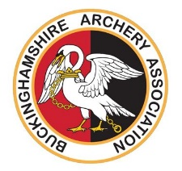

Buckinghamshire Archery Association

Coaching Course Reimbursement Policy

Buckinghamshire Archery Association (BAA) aims to grow the number and level of qualified coaches within the county, with the goal of every club in the county having at least one coach..

To this end, Buckinghamshire Archery Association aims to reimburse £200 of the cost of achieving an Archery GB coaching qualification. In order to achieve an Archery GB coaching qualification, candidates must be members of Archery GB.

Candidates are required to book and pay for all of the relevant course modules (including safeguarding) themselves and apply to the county for reimbursement of the £200 on achieving the qualification. Receipts must be provided to the County Coaching Organiser for all course modules, together with confirmation of a successful DBS check and the qualification certificate from Archery GB.

This funding is offered on the condition that, once qualified, the coach attends at least two county coaching events each year and at least two county coaching meetings or CPD events each year for two years after qualifying.

If the coach leaves the county within two years of qualifying, the coach is required to pay back the £200 to Buckinghamshire Archery Association.

Coaches applying for the funding will be required to sign a letter confirming their acceptance of these conditions before funding is provided.

Note that Instructor courses offered by Archery GB are outside the scope of this policy and Buckinghamshire Archery Association will not offer any funding for these courses.

