|  |  |  |  |  |  |  |  |
| --- | --- | --- | --- | --- | --- | --- | --- |
| Team Name |  |  | | Gender | Male  | | Female  |
| Bowstyle | Compound  | Recurve  | Longbow  |  |  | Barebow | |
| Archery GB County |  |  | |  |  | | |

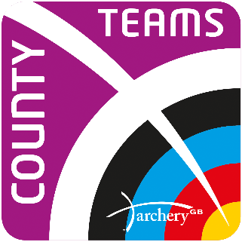 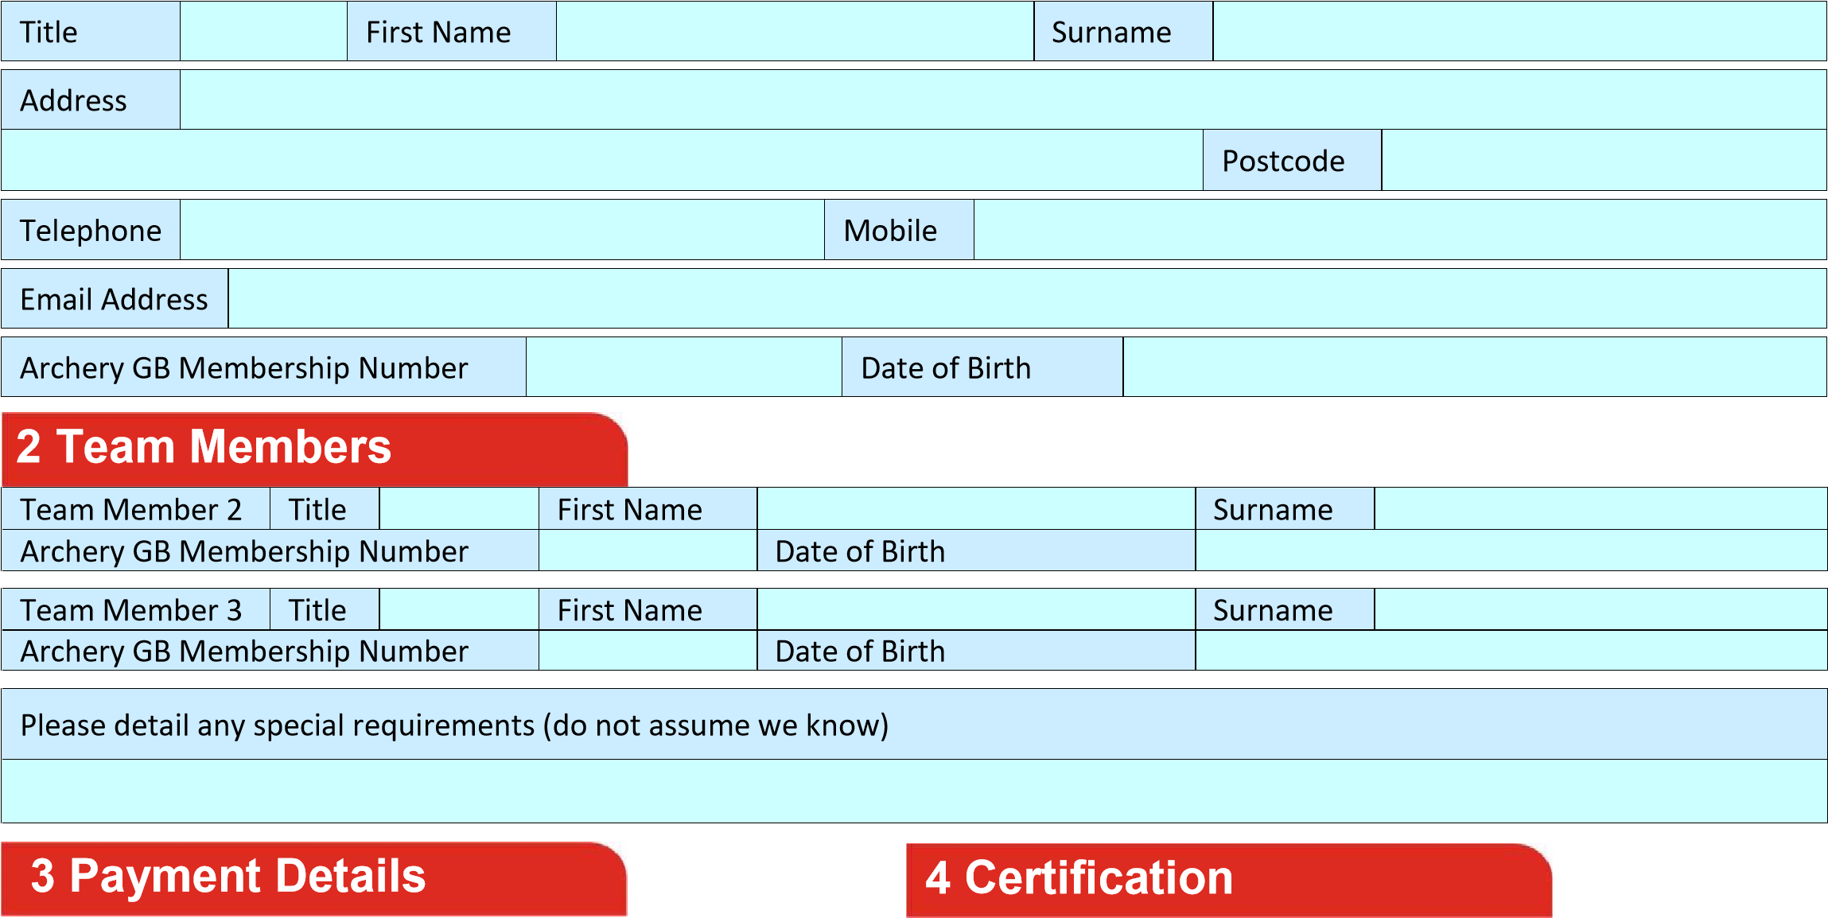

Team Entry Form

## **National County Team Championships 2022**

**Please use block capitals and black or blue throughout the form**

**Team and Contact Details**

|  |  |  |  |  |  |  |  |
| --- | --- | --- | --- | --- | --- | --- | --- |
| Team Entry Fee Per Team £145 | | ❑ |  | I certify that all the Archers named on this form are members of Archery GB and that they will abide by all the regulations and requirements as detailed in the Tournament Prospectus.    Team captains must collect a signature from a parent/guardian of all archers under 18 indicating that they give consent for the juniors named on this form to be drug tested if applicable.  Photography - I confirm I am happy that images/video of me can be taken and that such images may be used by Archery GB.  Archers under the age of 18 must also obtain parental/guardian approval for their images/videos to be taken/used. | | | |
| All camping is now booked direct through Lilleshall. Details on the Lilleshall Website. | | |  |
| Total to be received by cheques payable to Archery  GB | £ | |  | I certify that this entry has been agreed by the County Organisation | | | |
|  | Position held in County |  | Signature |  |

1. **Return to the Archery GB organiser**

Archery GB, Lilleshall National Sports Centre, Newport, Shropshire, TF10 9AT

Email: nctc@archerygb.org

1. **Tournament Secretary’s Use Only**

|  |  |  |  |  |  |  |
| --- | --- | --- | --- | --- | --- | --- |
| Entry ID |  | Membership Services  | Cash  | Cheque  | Cheque IDs |  |

Archery GB is the trading name of the Grand National Archery Society, a company limited by guarantee no. 1342150 Registered in England