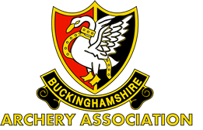**Buckinghamshire Archery Association**

**County Field Shoot**

If you've never tried field archery before this event is a good introduction. Yes, there are medals to be won, but the emphasis is on enjoying a day’s shooting in a friendly and relaxed atmosphere.

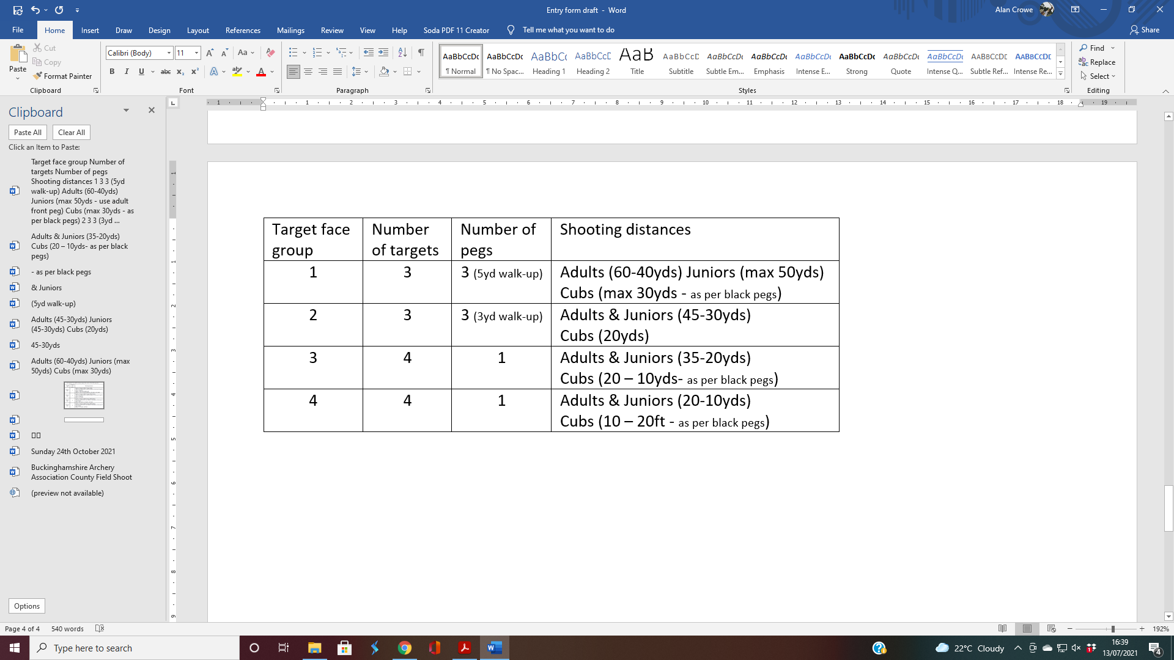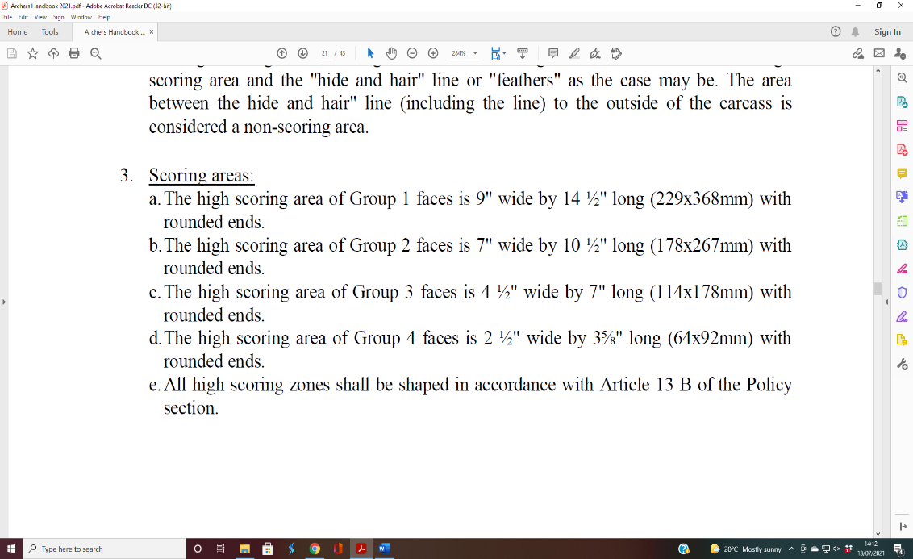The round is 28 (2x 14 with a lunch break in between) animal picture targets that are shot at from marked distances in the range of 20ft to 60yds ( Junior: 15-17yrs max distance = 50yd; Cub: 14yrs and under max distance 30yd.) The distance shot is in direct proportion to the size of the scoring area, of which there are two - kill and wound.

For each target you will have a maximum of three shots to get a scoring arrow, and the scoring is as follows:

* 1st arrow kill 20 wound 18
* 2nd arrow kill 16 wound 14
* 3rd arrow kill 12 wound 10

Arrows:

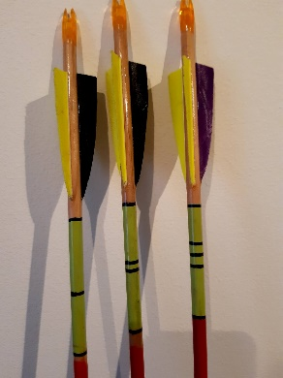***An archer’s arrows must be clearly identified with one, two or three rings at the back of the arrow***. Arrows are to be shot in ascending order. If an arrow is shot out of order, the archer is to advise the Target Captain who will direct the sequence for the remaining arrows

White Mark Bowmen's course is in a reasonably flat woodland setting that may be muddy depending on the weather and so trainers or walking boots are recommended.

Tea and coffee will be available.

**GDPR** – “When you enter competitions the following information may be collected and shared with tournament organisers, scoring systems and other competitors for example target lists and results may be published: First Name, Surname, Gender, Bow style, Date of Birth / Age category, Email, Address, Phone number, Club (and ID), County (and ID), Region (and ID), Round (unless defined by age), Disabled (Y/N), Disability info. ¨